#### MONTANA STATE UNIVERSITY

Department of Mechanical and Industrial Engineering

ETME 489R-001 CAPSTONE: MECHANICAL ENGINEERING TECHNOLOGY DESIGN I

and

EMEC 489R-001 CAPSTONE: MECHANICAL ENGINEERING DESIGN I

Battle Bot Group 3

by

Cole Trugman

Ivan Albert

Nishagar Raventhiran

for: {Rob Larson, David Miller, Craig Shankwitz, and James Black}

Prepared to Partially Fulfill the Requirements for EMEC 489/ETME489

Department of Mechanical Engineering Montana State University Bozeman, MT 59717

December 10th, 2018

#### Executive Summary

This ME/MIE capstone battle-bots project is intended to showcase student design and innovation in a challenging, fun, and entertaining event. The objective during the competition is to disable the opponents battle-bot while surviving to fight in the following 3-minute-long round after an allowed 5 minute “pit stop”, all while being prepared to maneuver around arena obstacles designed by another group to hinder and damage the bots. The design goal being to create an original design consisting of a unique primary armor and weapon structure utilizing either new or re-purposed motors, batteries, and drive system.

Aside from good sportsmanship/conduct, the competition guidelines provided most of the design constraints and considerations. These constraints include but are not limited to: bot weight, bot size, weapon limitations (such as no flames, explosives, blades, or chemicals), cost ($500-$1000), and include a master power disconnect switch.

The method used to ideate and build a formidable bot included spectating and studying televised battle bot competitions (as well less professional garage-built bots on Youtube) to take note of successful and unsuccessful bot shapes, sizes, weapons, defenses, and drive systems. This method led to the decisions of using a centrifugal force based “roller” to cause damage, a short, rectangular aluminum body to resist damage, and a repurposed Playstation 3 controller to communicate with and control weapon and drive motors.

Once a basic idea was decided upon, the object was to optimize drive speed, attack power (both deriving from motor size), attack resistance/component safety and the main limiter, weight. Initially 4 driving motors were desired, however, in order to allocate more power/weight distribution to the weapon a combination of gears and pulleys was designed so that all 4 wheels could be driven with only two motors. Similarly, an exterior armor plate harder/less malleable than aluminum was desired in the most critical areas of the bot. However, it was found though Solidworks finite element analysis that a slightly thinner steel plate of similar weight to a thicker aluminum plate would make little to no difference in the deflection/ stresses caused by a 100 lb force (which was determined to be a reasonable expectation for an opponent bot weighing 25lb to deliver).

These considerations resulted in a design that utilizes in line wheels driven by two motors to mobilize the bot, a quickly spinning “lawn mower” type roller for the weapon system, aluminum armor and mounting components, and a bluetooth controlled raspberry pi to send output signals to the wheels and roller.

The timeline for this project has been divided into two 4-month long phases aligning with the fall and spring semesters. The first phase, the design phase, began with ideation and very preliminary design packages. The project would slowly become more defined as more background research is completed. During November, preliminary designs would be refined and more carefully thought out until a complete drawing package, manufacturing plan, functional and budget analysis was created. By the end of finals week in December, all this would be turned in along with proof of purchase of components that had been called out in the drawings/manufacturing plan.

This would bring the project into the second phase where it would be ready to be machined, assembled, and tested in the spring (January-April) until it is ready for the competition sometime in May.

# Table of Contents

Cover Page…………………………………………………………………………………………………………………………………………… i

Executive Summary…………………………………………………………………………………………………………………………….. ii

Table of Contents……………………………………………………………………………………………………………………………… iiii

Chapter 1: Introduction……………………………………………………………………………………………………………………….. 1

Chapter 2: Problem Statement…………………………………………………………………………………………………………….. 2

Chapter 3: Background…………………………………………………………………………………………………………………………. 3

Chapter 4: Design Specifications…………………………………………………………………………………………………………… 4

Chapter 5: Design Alternatives & Specifications……………………………………………………………………………………. 5

Chapter 6: Description of Design……………………………………………………………………………………………………………

Chapter 7: Conclusion………………………………………………………………………………………………………………………….

References & Bibliography…………………………………………………………………………………………………………………

Appendix A: Analysis………………………………………………………………………………………………………………………..

Appendix B: Manufacturing Plan………………………………………………………………………………………………………..

Appendix C: Project Schedule…………………………………………………………………………………………………………….

Appendix D: Purchased Parts List……………………………………………………………………………………………………

Appendix E: Engineering Drawings………………………………………………………………………………………………….

Appendix F: Economic Analysis………………………………………………………………………………………………………..

Appendix G: Project Academic Assessment……………………………………………………………………………………..

# Chapter 1: Introduction

As mentioned in the summary above, the reason for this project is to provide ME and MET students with a fun, challenging, innovative, and entertaining way to showcase their design, analysis, and manufacturing ability. The 10 students participating among the 3 battle bot groups are presented with the task of facing each other’s bots in combat. This requires sticking to the guidelines presented by the competition, disabling opponent bots, and surviving to fight another round. Because even if an opponent is disabled, a fourth group has been tasked with designing obstacles with the purpose of slowing down, damaging, and potentially disabling the winner bot resulting in a draw between the three competitors. The style of this competition also makes this project unique because it requires anticipation of potential threats as well as potential defenses to get through resulting in additional creativity required when attempting to design a well-rounded fighter/defender.

This task of anticipating enemy bots and building something well rounded to combat them becomes especially challenging when presented with the current rules and regulations. The 25lb weight limit and 18” x 18” x 18” size limitation forces the team to optimize the allocation of weight and space to offense, defense, drive speed, etc. On top of opponent bot anti

# Chapter 2: Problem Statement

# Problem

The design goal is to create a remote-controlled robot capable of immobilizing other robots. The machine must fulfill all of the level one requirements listed below. It will be placed in the ring with two other robots built by other teams for the same purpose. For three minutes the robots will fight each other attempting to render the others helpless or immobile. The competition will last for a series of three three-minute rounds which will be separated by five-minute breaks to repair the robots. Judges will award points based on the robots’ performances to determine the winner.

## Level One Requirements

Basically, the level one requirements for the team were drawn from the competition rules. They are listed as follows,

* Less than 25 lbs
* Fits in 18 in cube
* Must be able to move under its own power
* Must be able to be controlled remotely
* Adheres to weapon limitations
  + No flames or flaming liquid
  + No chemical weapons
  + No untethered projectiles
  + No explosives or explosively-driven weaponry
  + No blades, spears, or edged weapons
* Costs less than $1000
* Able to run for 3 minutes on one charge
* Not a preassembled robot or toy
* No unsportsmanlike conduct

# Background

From studying Battlebot competitions, a few archetypes become evident among the serious competitors. One such archetype is to have a bot with a fast spinning blade to try and shred the opponent. Another common design uses a mechanism such as a claw to try and grab the other robot and move them into obstacles. Some successful bots utilize a studded roller on the front of the bot that spins at high speed and charges the opponent to try and flip them. “Spatula” style flipping bots are also common, which slip an arm or mechanism under the opposing bot and use that to flip them. Robots that hammer the opponent with a large weapon arm often do well and can cause a lot of damage. These archetypes provide not only a starting point for deciding what our robot will do, but a point of reference for what our robot may have to face.

Consideration of different potential opponents lead to consideration of different materials to use in response to such opponents. These preliminary considerations include that for electronic housing, armor, chassis, and wheels. (Factors of each include Strength/durability/toughness vs weight/cost/machinability/allowance for heat flow away from electronic components). For example, using aluminum 6061 for parts of chassis which do not have to withstand much abuse is one initial idea. 6061 is lightweight and easily machined. It is also easily welded. The tradeoff is that (compared to steel or even al 7075) it has lower strength and hardness. 7075 however is much less easily machined or welded. It would be best used as an outer layer of armor which does not have to be welded to or interact with other components other than the chassis. Simple geometry could be used to limit the manufacturing of 7075. UHMWPE is also a material that could be used to make armor. UHMWPE has an extremely high yield point, and for a 25-pound bot, is nearly unbreakable yet is able to deform enough to dampen a heavy impact without fracture.

As for mobilization, after studying many battle bot competitions, it seems that the most common steering system is a dead axle “tank” type control system. Meaning that the left and right drivers are independent and used to steer left or right based on which motor is causing the most displacement. The turn radius and response time is dictated by the distance separating inline wheels as well as distance between parallel pairs. Several sizes and materials for wheels are available. After reading blogs published by other bot builders and by going to websites such as BaneBots.com (which manufactures quality yet affordable bot components including motors, wheels, gearboxes, etc.), it seems that Colson wheels are a good option, they are made of a durable lightweight propylene core with a thermoplastic rubber tread which will provide excellent traction on the concrete/asphalt arena. Banebots also manufactures affordable motors available in a large variety of sizes, voltages, speeds, torques, and prices. The selected motor for this bot will also depend on the input/output voltage of the selected control system.

For the electronic control systems on the project, Arduino based microcontrollers are an attractive option. Many of these microcontrollers are inexpensive and Arduino is widely used by hobbyists, so resources are abundant. Arduinos also come in many shapes and sizes with different features, inputs and outputs. Keeping the electronics cheap and modular will be an important aspect to pay attention too.

Another option for the control system would be to take apart a second-hand remote-controlled vehicle and use its receiver and components. A remote-controlled plane might be a good option as they have more control surfaces and servos than a car.

Communication with the robot can be achieved in many ways. Wi-Fi, Bluetooth and radio based communication are three viable options. Transmitters and receivers for radio based controls are used by hobbyists for remote-controlled planes and cars and off the shelf parts can be found readily. Wi-Fi and Bluetooth receivers for Arduino units are also common, and may allow control from a phone. PlayStation 4 controllers also communicate via Bluetooth, which might provide an off the shelf controller for the robot. Bluetooth protocols are well documented and widely available.

# Design Specifications

Due to the fact that this project proposal is a type of competition and lacks both a sponsor and firm/OSHA/professional/industrial standards, many specifications will be either required by the competition guidelines or the personal targets for the group. The specifications were categorized as follows;

Offensive/defensive Specifications:

* The robot must be able to push with a force of 20 lb. This is to ensure it can move opponents and obstacles. This is based on the fact that rubber on asphalt has a coefficient of kinetic friction between 0.5 and 0.8. (25lb * 0.8 = 20lb)
* The robot can also withstand 20 lb of pushing force from opponent, based on friction and motor stall torque.
* The robot must be able to withstand at least 25 lb added weight in case another bot gets on top of it.
* The robot must move under its own power at a minimum speed of 1 foot per second.

Assembly Specifications:

* The battery should provide enough power to run the robot for 3 minutes continuously and be replaced or charged in under 5 minutes.
* The turning radius of the robot has to be at least 3 ft

Interface Specifications:

* The robot must include a master power disconnect switch
* The control system must interface with driving motors as well as a remote control, which must maintain a reliable connection over a distance of at least 33.28 ft. This was calculated by finding the corner to corner span of the arena and adding 5 feet

$$\left(\sqrt{{\left(20\right)}^{2}+{\left(20\right)}^{2}} +5\right)feet$$

Material Specifications:

* Device (Not including peripheral equipment) must weigh between 20 and 25 lb in order to meet requirements and not be pushed around easily.
* Device must stow into an 18” cube.
* Device must not have sharper than 1/8” radius edge.
* Device should cost between $500-$1000 and include receipts.

Basic numerical values that can be achieved were assumed, and the calculations were made based on those values. As the project progresses, with more research and testing, the values can be increased or decreased according to the need of overall performance of the Battle bot.

# Design Alternatives Creation and Evaluation

Ideas were brainstormed for each of the subsystems of the robot. These design options were then evaluated and compared to one another based on how they would perform in different areas of that system’s function. A simple point scale was used which ranges from -2 to 2, where 0 shows that a design does not stand out in any meaningful way, 1 or -1 indicated that the design filled that criteria well or poorly, and 2 or -2 showed that the design especially stood out in that regard, either positively or negatively. 2 and -2 scores are also highlighted in green and red respectively as an additional visual indicator.

## Drive and Steering

|  |  |  |  |  |  |
| --- | --- | --- | --- | --- | --- |
| **Drive System** | **Maneuverability** | **Ease of Implementation** | **Durability** | **Cost** | **Total Points** |
| **Live Axle** | -1 | 0 | 1 | 2 | 2 |
| **Dead Axle** | X | X | X | X | X |
| **Wheels** | 1 | 2 | 2 | 1 | 6 |
| **Tank Treads** | 1 | 1 | 0 | 0 | 2 |
| **Omni Wheels** | 2 | -1 | -1 | 0 | 0 |

The live axle design is driven by a main motor and steered by changing the angle of wheels, much like how a car drives. This uses the least motors, reducing cost, but is the only option that cannot turn in place.

The dead axle design has a left and right side that are independently controlled and turns by the difference in speed between the two. This can be done with traditional wheels, or tank treads. Tank treads would be more complicated to set up and leave themselves vulnerable if the track is removed.

The omni wheels design uses four angled omni wheels to allow complete freedom of movement. It can turn in place and even drive sideways or at an angle, however it requires more motors and more involved programming to function.

## Electronics

|  |  |  |  |  |  |
| --- | --- | --- | --- | --- | --- |
| **Electronic Control System** | **Ease of Implementation** | **Reliability of Control** | **Versatility** | **Cost** | **Total Points** |
| **Off the Shelf RC Parts** | 2 | 2 | -2 | 1 | 3 |
| **Arduino** | X | X | X | X | X |
| **Bluetooth** | 1 | 1 | 2 | 1 | 5 |
| **Wi-Fi** | 0 | 1 | 1 | 1 | 3 |
| **Radio** | -1 | 2 | 2 | 1 | 4 |

Using off the shelf RC parts such as from an RC car or plane would provide a proven transmitter, receiver and some motors and servos, but would be difficult to modify for a robot with more things to control or which drives differently.

Using an Arduino microcontroller would require the design and programing of the electronics needed but would have inputs and outputs that could be easily modified to fit the needs of the robot. An Arduino could be controlled in a few different ways. Radio would have the longest range and clearest signal but may be difficult to decode on the Arduino’s end. Bluetooth protocols are well documented and components for it are readily available for Arduino. Bluetooth is also used by off the shelf PlayStation 4 controllers.

## Weapon

|  |  |  |  |  |  |
| --- | --- | --- | --- | --- | --- |
| **Weapon System** | **Damage** | **Ease of Implementation** | **Ease of Use** | **Cost** | **Total Points** |
| **Hammer** | 2 | 1 | 1 | 0 | 4 |
| **Roller** | 2 | 1 | 2 | 0 | 5 |
| **Hydraulic Wedge** | 0 | 0 | 1 | -1 | 0 |
| **"Hermit Crab"** | 1 | 1 | -1 | 1 | 2 |
| **Spatula** | 1 | 0 | 0 | -1 | 0 |

Hammers are mechanically simple and capable of a lot of destruction but are heavy which will affect the available weight for the rest of the robot.

Rollers use a studded cylinder that rotates at high speed on the front of the robot which can cause damage both by throwing opponents, and by tearing at them with studs. They are versatile and do their job as long as the robot drives forward into the opponent.

A hydraulic wedge design uses a wedge-shaped vehicle with a sloped face that can be tilted forward by hydraulic piston. It would attempt to drive into opponents and flip them over.

The “hermit crab” idea involves making a robot that other bots can easily drive onto and baiting them into doing so. One on top, a set of powerful magnets would trap them in place. They are then the “shell” of the hermit crab as it fights the other robot.

Spatula weapons use a flat implement which they attempt to slide under the opponent, which is then rapidly raised to flip the opponent over.

## Armor

|  |  |  |  |  |  |
| --- | --- | --- | --- | --- | --- |
| **Armor** | **Strength** | **Ease of Implementation** | **Weight** | **Cost** | **Total Points** |
| **Aluminum** | 0 | 2 | 1 | 0 | 3 |
| **1018 Steel** | 1 | 1 | 0 | 0 | 2 |
| **UHMWPE** | 2 | -1 | 1 | -1 | 1 |
| **AR400 Steel** | 2 | -2 | 0 | 0 | 0 |

Aluminum armor would be relatively easy to machine and is a light option as metal armors go.

Steel is more difficult to work with than aluminum and heavier, but also stronger.

UHMWPE (Ultra-High-Molecular-Weight Polyethylene) is a plastic which will make it harder to work with than metal with the available facilities but can have much lower density than aluminum and is notoriously durable, even being used in body armor.

## Design Ideas

|  |  |  |  |  |  |
| --- | --- | --- | --- | --- | --- |
| **Design** | **Drive System** | **Electrical System** | **Weapon** | **Armor** | **Total Points** |
| **Design 1** | **Dead Axle: Wheels** | **Arduino: Bluetooth** | **Roller** | **Aluminum** |  |
| 6 | 5 | 5 | 3 | 19 |
| **Design 2** | **Omni Wheels** | **Arduino: Radio** | **Hammer** | **UHMWPE** |  |
| 0 | 4 | 4 | 1 | 9 |
| **Design 3** | **Dead Axle: Wheels** | **Arduino: Bluetooth** | **Hydraulic Wedge** | **1018 Steel** |  |
| 6 | 5 | 0 | 2 | 13 |

Design 1 combines the highest scoring systems of each category.

Design 2 is an extremely maneuverable hammer bot which uses plastic armor to reserve weight for the hammer.

Design 3 is a hard steel ramming wedge.

# Description of Project/Design

# Conclusions

# References

# Appendix A: Analysis

# Appendix B: Manufacturing Plan Appendix C: Project Schedule

# General Roll assignment:

Based on each group members particular experience, general rolls were assigned for building/assembly of the bot.

Electronics: Assigned to Ivan for mechatronics minor/experience

Fabrication: Assigned to Cole for FEA/welding/machining through MET.

Organization/model management: Assigned to Nishagar

# Term Meeting Schedule/ Location:

This varies by week due to everyone’s work schedule, however all three gather every Wednesday at 2:00 pm to touch base, assign responsibility until the following meeting if we are unable to gather again, and otherwise decide our next meeting time before the following Wednesday. This time is also used to consult with our advisor, Professor James Black.

# File Sharing

During the first scheduled meeting it was decided that GitHub would be our method of editing/sharing files via a shared repository. It is excellent at saving old versions of texts, spreadsheets, and models, and each member has an individual copy on his hard drive until they are ready to be merged.

# Group Leadership Schedule/Member Assignments:

# 9/12/18 Leader: Cole

* Meet advisor and set up weekly meeting time/place
* Deliver first progress memo
  + Assigned to group

# 9/19/18 Leader: Cole

* Level 1 requirements started
* Ongoing group rules document updated
* Wrote problem statement
  + Assigned to Ivan Albert
* Started Gantt chart
  + Assigned to Cole Trugman
* Start background section
  + Assigned to Nishagar

# 9/26/18 Leader: Ivan

* In coming week will start on design specifications
* Combined individual background sections

# 10/03/18 Leader: Ivan

* Nishagar and Cole were assigned to Level 1 Design Specifications
* Ivan was assigned to Design alternatives.
  + - Making tables with ranking -2 to 2 gives a clear picture of the ideas the team have and their effectiveness
* Discussed possible design and the requirements
  + - Can have both fast rollers in the front, and the wedge in the back as a defense weapon system
    - The direction of the rollers effects the motion of the bot when hits the opponent.

# 10/10/18 Leader: Nishagar

* Turn in design specs and alternatives draft
* Decided to design for a minimum pushing/push resisting force of 20 lb.
* Decided to design for a minimum speed of about 1 fps both as a defensive tactic as well and a way to make the wedge offensive.
* Discussed utilizing aluminum 6063 for its light weight and easy machinability/weldability with the possibility of implementing a thin (1/8”) layer of ar400 steel to protect the soft aluminum
* See “design specs” for other choices made this week.

# 10/17/18 Leader: Nishagar

* Update Master Project Plan (Started virtual design journal through github where it is accessible/ changeable for all members to record design ideas)
  + Assigned to Cole
* Started google doc for design journal/ place for sharing new thoughts/design ideas.
* Turn in weekly progress memo

# 10/24/18 Leader: Cole

* Perform peer review
  + Assigned to group
* Prepare/present preliminary design
  + Assigned to group (Meet Saturday 10/20 to finalize powerpoint)

# 10/31/18 Leader: Cole

* FMEA
  + Electronics Assigned to Ivan
    - Microcontroller (motor control), Battery, wiring, code, Drive/Weapon Motor, Peripheral Controller,
  + Assigned to Cole:
    - Roller failures (Bent axle, motor/roller connection, )
    - Chassis (Component protection, structural integrity)
  + Assigned to Nishagar
    - Manufacturing/Process (Tolerances, machining, assembly issues, competition rules)
    - Wheel Sub-assembly (bent/sheared axle, shape abnormalities, lost/damaged wheel, damaged bearing)

# 11/7/18 Leader: Ivan

# Master Project Schedule Update

* + Assigned to Ivan
* Division of jabs for the coming week
  + Nishagar assigned to failure calculations
  + Ivan assigned to component selection
  + Cole assigned to model finalization

# 11/14/18 Leader: Ivan

* Progress Memo
  + Assigned to Cole

# 11/21/18 Leader: Nishagar

* Progress Memo
  + Assigned to Ivan

# 11/28/18 Leader: Nishagar

* Critical Design Review (CDR)
  + Group assignment
* Draft Analysis and Manufacturing Plan Appendix
  + Assigned to Cole and Nishagar
* Progress Memo
  + Assigned to Ivan

# 12/5/18 Leader: Cole

* Progress Memo
  + Assigned to Nishagar
* Course Evaluation
  + Assigned to each member of the team
* Peer Evaluation
  + Assigned to each member of the team
* Advisor Evaluation
  + Assigned to each member of the team

# 12/12/18 Leader: Cole

* Final written report due Monday (Includes "Drawing Package"  
  and "Manufacturing Plan" Appendices, Updated Master Project Schedule, and all other elements defined on website format guide.)
  + Assigned to group
* Complete orders and supporting documentation
  + Assigned to Ivan
* Deliver CDRs by Tuesday 6:00 pm
  + Assigned to Cole
* Progress Memo
  + Assigned to Nishagar

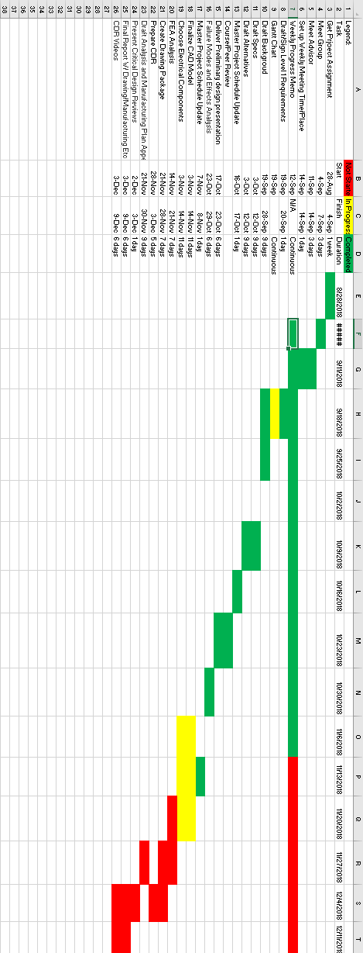

# Appendix D: Purchased Part List

The team has made a list of materials need to be purchased, and planning to handover to the advisor by the end of the week of 12/10/2018 for purchasing. Most of the parts are to be ready to buy materials which will be cut into desired sizes and weld or screw together to make an assembly. This will allow the manufacturability easy and time conservative for the team. The parts needed are listed in the following appendix of Project economic analysis.

# Appendix E: Engineering Drawings

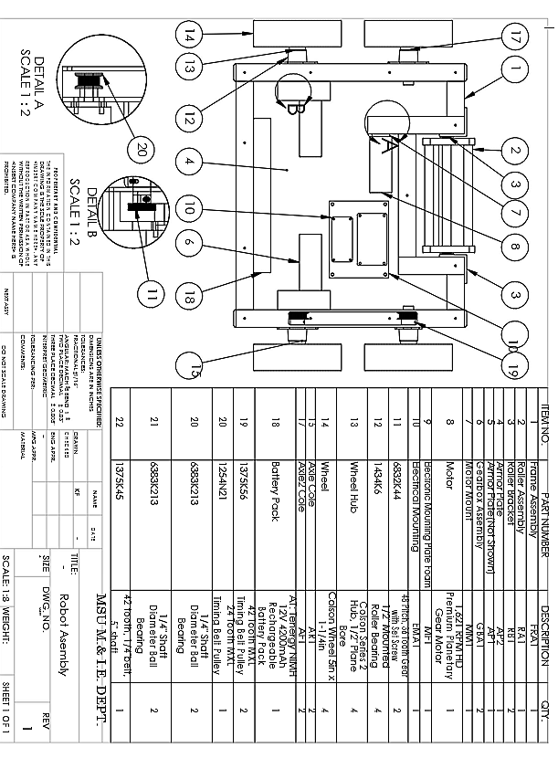

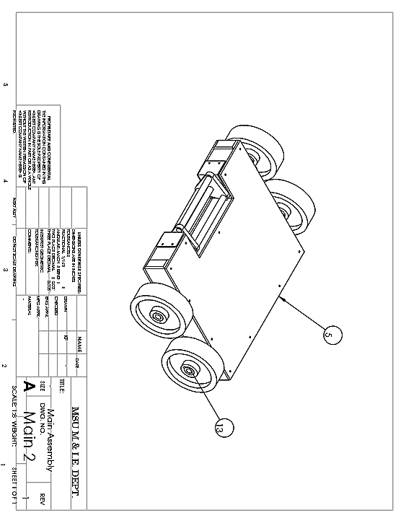

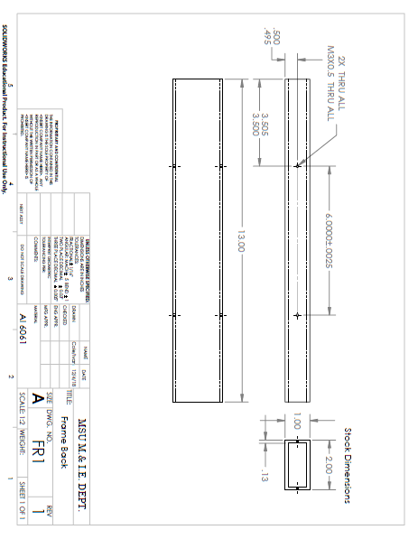

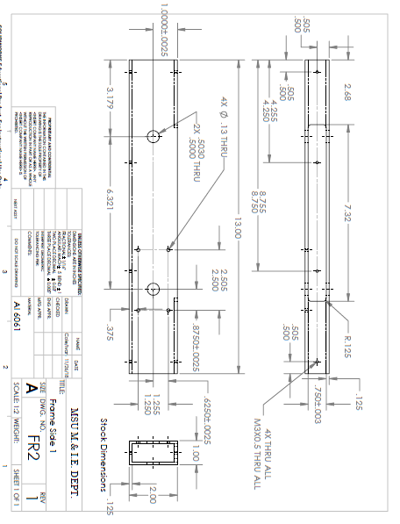

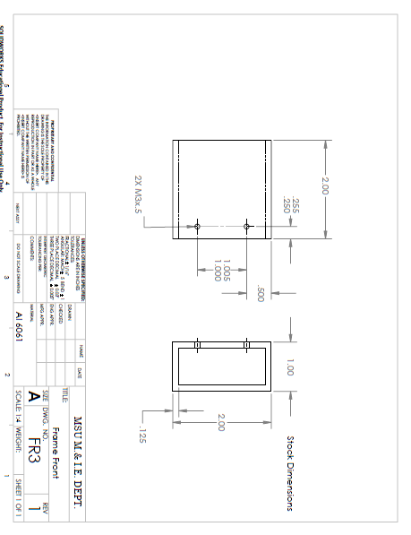

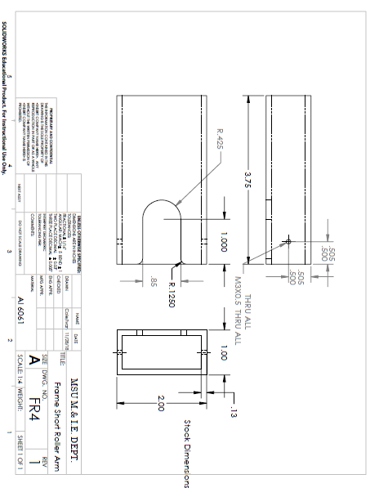

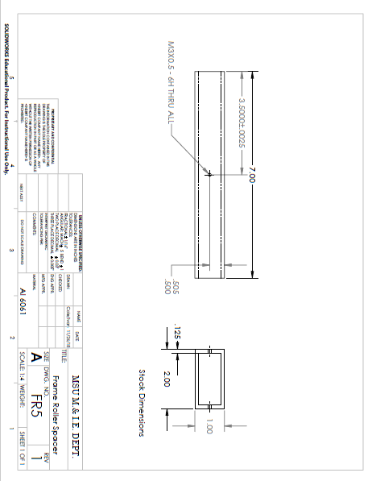

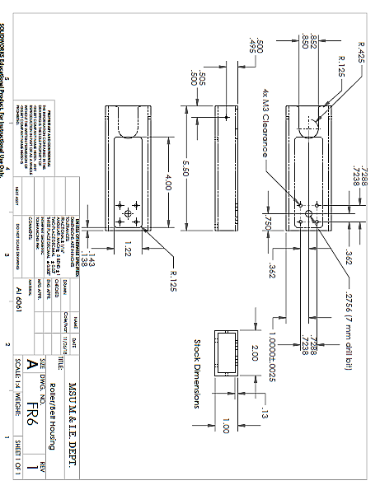

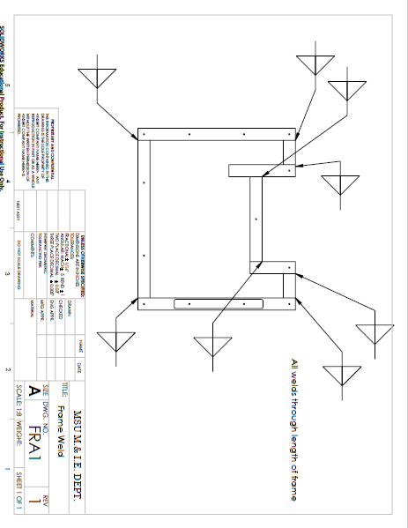

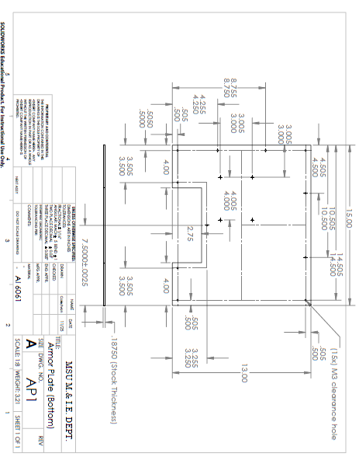

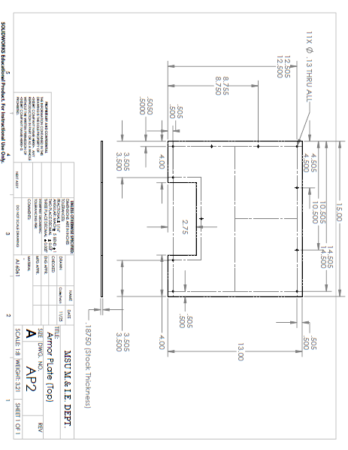

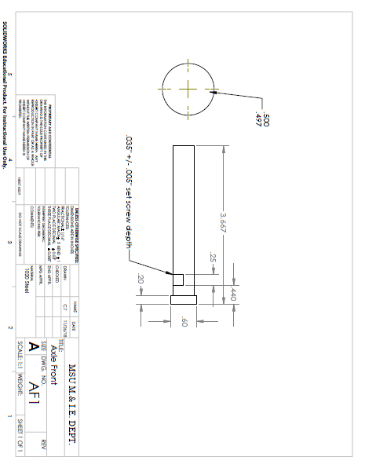

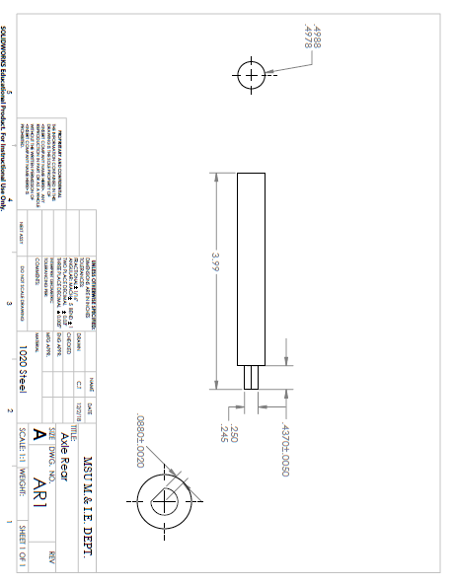

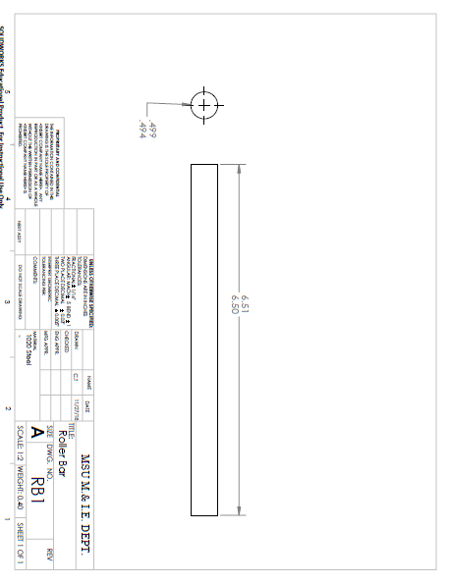

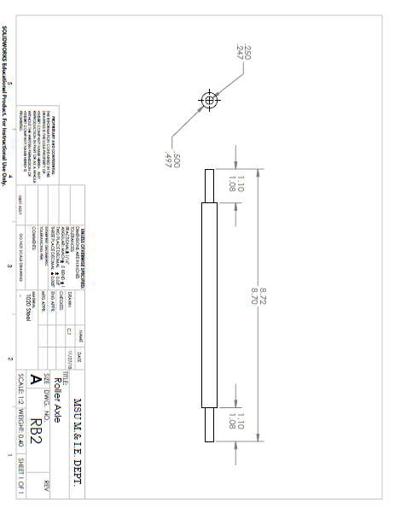

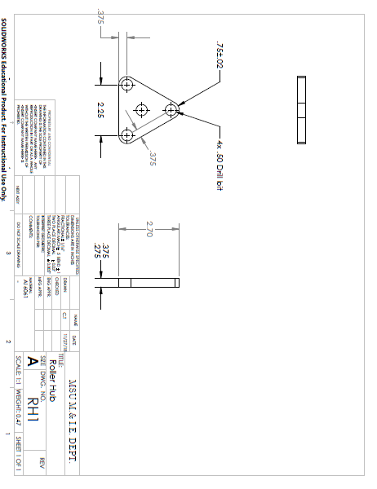

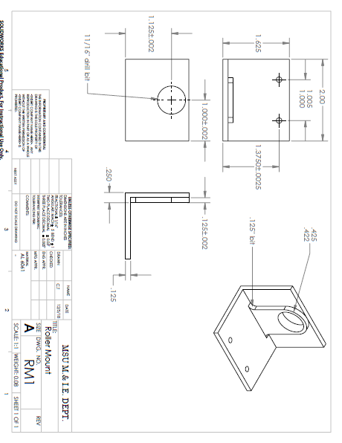

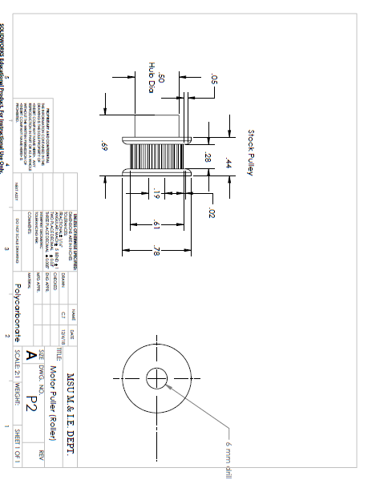

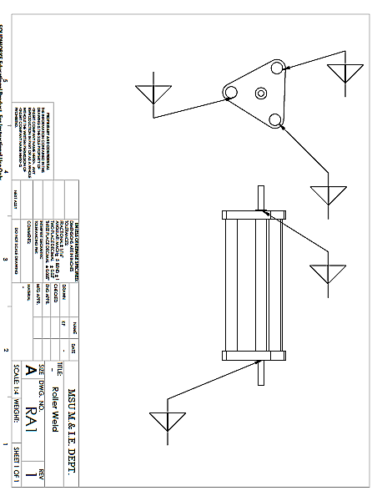

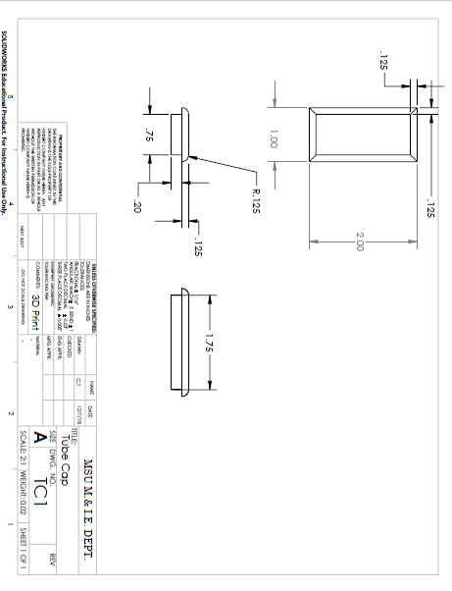

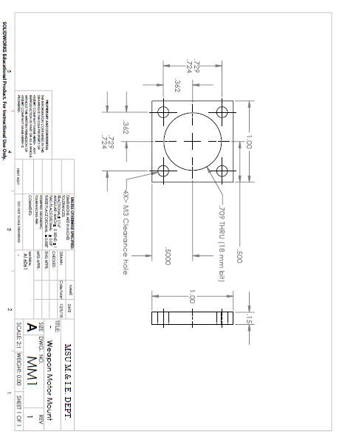

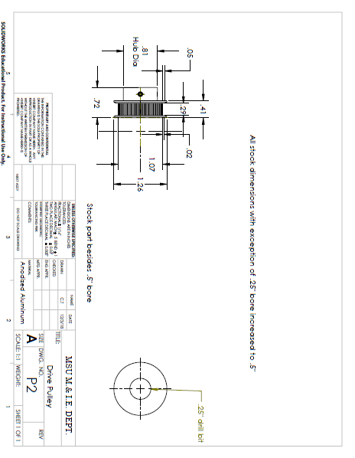

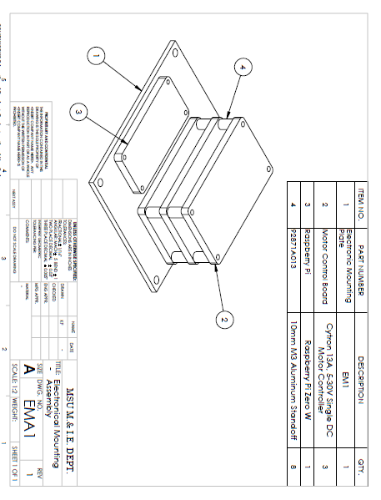

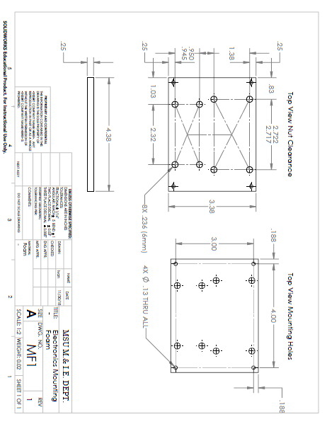

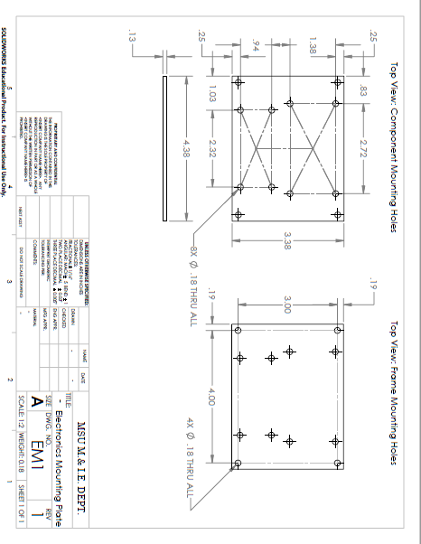

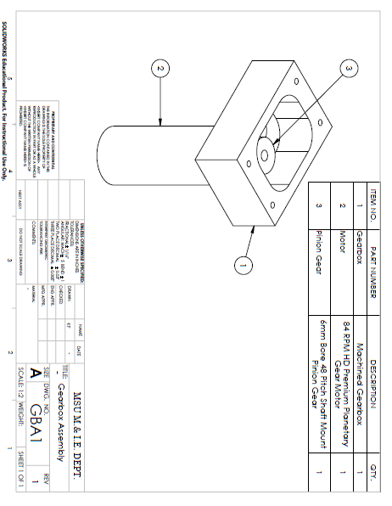

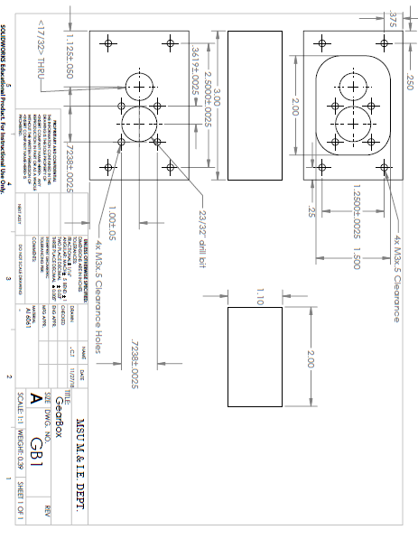

# Appendix F: Economic Analysis

The budget plan given below in the table is the expected cost to build the battlebot. The team will start ordering the parts by the mid of December 2018: after finalizing the design. As for now, the budget is under control with estimated cost of 72.63% of the total budget limit. As progress, if the budget exceeds the limit; the design can be altered in order to reduce the parts and materials used to manufacture the Bot, as the design contain more empty space.

Table 1 : Materials need to be Purchased

|  |  |  |  |  |
| --- | --- | --- | --- | --- |
| **Part Number** | **Description** | **Quantity** | **Unit cost** | **Total Expected Cost** |
| 1 | 165 RPM HD Premium Planetary Gear Motor | 2 | $39.99 | $79.98 |
| 2 | **Cytron 13A, 5-30V Single DC Motor Controller** | 4 | $13.82 | $55.28 |
| 3 | Raspberry Pi Zero W | 2 | $10.00 | $20.00 |
| 4 | Tenergy NiMH 12V 4200mAh Rechargeable Battery Pack | 2 | $69.99 | $139.98 |
| 5 | RC Servo BEC UBEC 3A 5V ( Receiver servo Power supply) | 1 | $7.99 | $7.99 |
| 6 | 1,621 RPM HD Premium Planetary Gear Motor | 1 | $39.99 | $39.99 |
| 7 | 6063-T52 Aluminum Rectangle Tube (2X1X1/8 Wall) | 1 | $32.15 | $32.15 |
| 8 | 11 GA. (.120 thick) Hot Rolled Steel Sheet (2'X4') | 1 | $77.00 | $77.00 |
| 9 | 5/8" Hot Rolled A-36 Steel Round | 1 | $5.14 | $5.14 |
| 10 | 1/2" Hot Rolled A-36 Steel Round | 1 | $6.60 | $6.60 |
| 11 | Bearing | 4 | $11.00 | $44.00 |
| 12 | Roller Bearing | 2 | $10 | $20.00 |
| 13 | Pulley | 4 | $16.00 | $64.00 |
| 14 | Driving Belt | 2 | $6.00 | $12.00 |
| 15 | Gears | 2 | $22.00 | $44.00 |
| 16 | Gears | 2 | $13.00 | $26.00 |
| 17 | 5" wheels/hubs | 6 | $16.00 | $96.00 |
| 18 | Screws | 1 | $20.00 | $20.00 |
|  |  | **Total** |  | $790.11 |

There is a possibility to change the design with some modification of sizes as the metals cost more than the team expected. Initially the top and bottom plate; which will act as the body armor was considered to be Aluminum as it is the light weight material than steel. But the minimum cost of the Aluminum of the required size was $101.00. So, the team have decided to purchase 11 Gauge Hot rolled Steel sheet which will cost $24.00 less than the Aluminum. It also adds the advantage of strong protection than Aluminum to the Bot. on the other hand, the total weight of the Bot has to reconsider with the design.

The manufacturing plan is mostly based on CNC machining and welding. The screws will be used to fasten the components to the base. So, the estimated manufacturing expenses are listed below in the table. Fortunately, these manufacturing costs are waived by allowing the team to work and use the materials in the university makerspace for free.

Table 2: Manufacturing Cost

|  |  |  |  |
| --- | --- | --- | --- |
| **Description** | **units** | **Unit cost** | **Total expected cost** |
| CNC lathe | 3 hrs | $90/ hr | $ 270.00 |
| CNC milling | 3 hrs | $90/ hr | $ 270.00 |
| Welding | 5 hrs | $60/ hr | $ 300.00 |
| Electrodes for welding | 2 boxes | $19.97/ Box | $ 39.94 |
| Conventional milling | 4 hrs | $75/ hr | $ 300.00 |
| Conventional turning | 4 hrs | $75/ hr | $ 300.00 |

Note that for the machining, two processes: CNC machining and Lathe machining are listed. But the team will mostly target to work on the CNC machine to get an accurate and easy manufacturing of parts. Also, these machining costs are based on the information provided on the internet resources and these are the average price ranges in the US and the hours mentioned in the table are rough approximate of how long it will take to manufacture the parts.

# Appendix G: Project Academic Assessment

|  |  |  |
| --- | --- | --- |
| Course number | Course | How it helped |
| EGEN 201 | Statics | Used to calculate the friction provided, minimum force from friction |
| EGEN 205 | Mechanics of Materials | Used to calculate torque, bending stress, shear stress of the structures |
| EMEC 103 | Computer Aided Engineering 1 | Gave basic Solidworks modelling, assemblies and drawing packages knowledge to start modelling |
| ETME 215 | Manufacturing Processes | Gave basic idea of how the parts are to be manufactured |
| EMEC 405 | Finite Element Analysis | Used to calculate how failure of each selected components occur |
| EMEC 342 | Machine component Design | Got some ideas of what bearings, and shaft features to be used |
| EGEN 310 | Multidisciplinary Design | Gave an idea of how to work with a group, with various helpful intro to the project management |